CSC1060 Computer Science I
Assignment
Objective
This assignment will demonstrate the process of using basic structures, mathematical operators, variable scope, methods and arrays. Only techniques taught in the course are to be used.
Submit
You are required to submit a copy of your source code file(s). Use the name TempConversion. Check the course assignment for the due date.
Description
Write a program that allows the user to convert temperatures to Fahrenheit, Celsius and Kelvin, then displays the values.

The program is to be menu driven. Validate user input for acceptable values. The program should display the following menu of selections:

- Convert Fahrenheit to Celsius
- Convert Celsius to Fahrenheit
- Convert Fahrenheit to Kelvin
- Display Data
- Quit Program
Enter your selection (1-5):

Assignment Specific Requirements:
- Write a main method to control the program. Within main when one temperature changes, change all temperatures – Fahrenheit, Celsius and Kelvin. All the new temperatures should be calculated and stored in a local array for output. Store each in their own array. Temperature conversions are only to be done within the methods designed for that purpose. Do not convert any temperature outside of those conversion methods.
- Write a return method named showMenu that displays the menu. This method should not accept any arguments but should return a valid selection value (1-5). Validation of the input should take place within showMenu. Output an appropriate error message to the user if the choice is not acceptable, then redisplay the menu. DO NOT CALL SHOWMENU FROM INSIDE THE METHOD.
- Write a return method named getTemperature(). It has one argument, the type of temperature being requested as a String data type – Fahrenheit, or Celsius. This text value should be concatenated with the prompt to the user. It should prompt the user to input a temperature and return that value to the calling statement. Validate input and output an appropriate error message.
- Write a return method named calcCelsius, which accepts the Fahrenheit temperature as an argument. The method should return the converted value to main for storage. Convert degrees F to C using the following formula:
    - C = (5/9)(F – 32)
- Write a return method named calcFahrenheit, which accepts the Celsius temperature as an argument. The method should return the converted value to main for storage. Convert degrees C to F using the following formula:
    - F = (C x 9/5) + 32
- Write a return method named calcKelvin, which accepts the Fahrenheit temperature as an argument. Convert degrees F to K using the following formula:
    - K = C + 273.15
    - or
    - K = (5/9)(F – 32) + 273.15
- Create a void method named displayData(), which receives three (3) arguments – the Fahrenheit, Celsius and Kelvin value arrays. Format output to two digits passed the decimal point. Trailing zeros should display. All decimal points should align in the columns of data when output.
- For every value entered, all three temperatures should be calculated – Fahrenheit, Celsius, and Kelvin.
- The program should continue to execute until the user enters 5 to quit the program.
- The program should accept both positive and negative temperatures.
- If the user selects an invalid choice from the menu, the program should display an appropriate error message and not return to main until a valid selection is made.
- Output data in an appropriately designed and labeled formatted table.

VTOC (Visual Table of Contents) Image
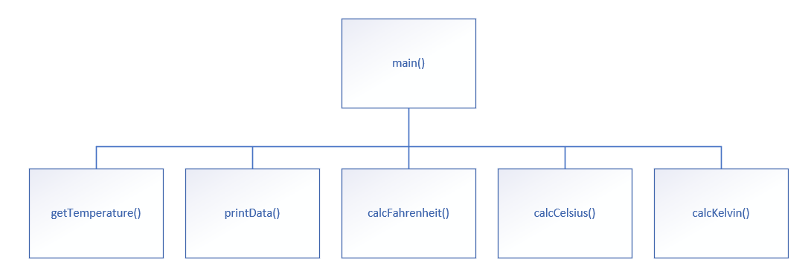

CSC 1060 Assessment Rubric:
Table 1: Rubric for CSC1060 Signature Assignment
 | Ready for Use  3 | Needs Minor Revisions  2 | Needs Major Revisions  1
Content  Requirements | - All program files submitted.  - Program performs as specified.  - Appropriate variable names used.  - Appropriate scope implemented correctly.  - Mathematical formulas implemented correctly.  - Proper input validation implemented correctly.  - VTOC design implemented properly.  - All methods designed appropriately.  - Appropriate calls made to convert methods.  - Data properly stored in arrays.  - Output appropriately designed. | - All program files submitted.  - Program performs well but not exactly according to specification.  - Most variables named appropriately.  - Scope mostly implemented correctly.  - Mathematical formulas calculate correct values.  - Input validation not implemented per requirement.  - VTOC design not implemented correctly.  - All methods mostly designed correctly.  - Appropriate calls made to convert methods.  - Data properly stored in arrays.  - Output acceptable but has issues. | - Not all program files submitted.  - Program does not perform as specified.  - Inappropriate variable names used.  - inappropriate scope implemented correctly.  - Mathematical formulas contain errors.  - Validation not implemented correctly.  - VTOC design not implemented properly.  - Not all methods designed appropriately.  - Inappropriate calls made to convert some methods.  - Data not properly stored in arrays.  - Output not designed per requirement.

